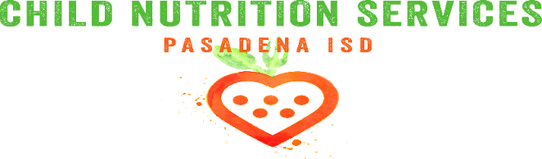
Important Reminders for the New School Year
- Meal Prices
  - Breakfast is free to all students
  - Lunch:
    - Reduced - $.040
    - Elementary - $2.20
    - Intermediate - $2.65
    - High School - $2.75
  - Adults/Visitor Prices:
    - Breakfast - $2.25
    - Lunch - $3.50
- Please submit a free and reduced application for 2017 – 2018 as soon as you can to continue meal benefits without interruption.
  - Applying online is fast and easy - www.schoollunchapp.com
- Paper applications are available at
  - Every Campus
  - The Child Nutrition Department
    - 1515 Cherrybrook, Pasadena 77502
- It may take up to 10 days for a paper application to be processed
  - If your application has not been approved by October 2nd please plan to send money or a lunch with your child on October 3.
- District Charge Policy as stated in the student handbook
  - Parents are strongly encouraged to continually monitor their child’s meal account balance. When a student’s meal account is depleted, the District will notify the parents via phone message and notices sent home with students. The student will be given a grace period of two days where lunches may be charged. If parents do not send payments for their outstanding account balance by the end of the grace period students will be offered a courtesy meal and campus administration will then follow up with parents. Ala Carte items may not be charged.
  - Prepayments can be made at the school or online at www.myschoolbucks.com

